**Laboratory Assignment 4: Design of Combination Logic Circuits**

**ECE 0201: Digital Circuits and Systems**

**45 Points**

**Name**

张鹤扬 Stefan

**Submission Checklist:**

 Write within boxes, do not move boxes

 Write your full name in the box above

 Save this file as a PDF before uploading, keep the number of pages (**14**) unchanged

 Note “TO BE CONTINUED” in the answer box if you used the extra pages (12-14)

**Part I: Logic Sources using DIP switches (7 points)**

**Four Logic Sources – Dip Switch and Four 1000 Ohm Resistors**

[(A) Insert a picture of your build of the circuit] (1 point)

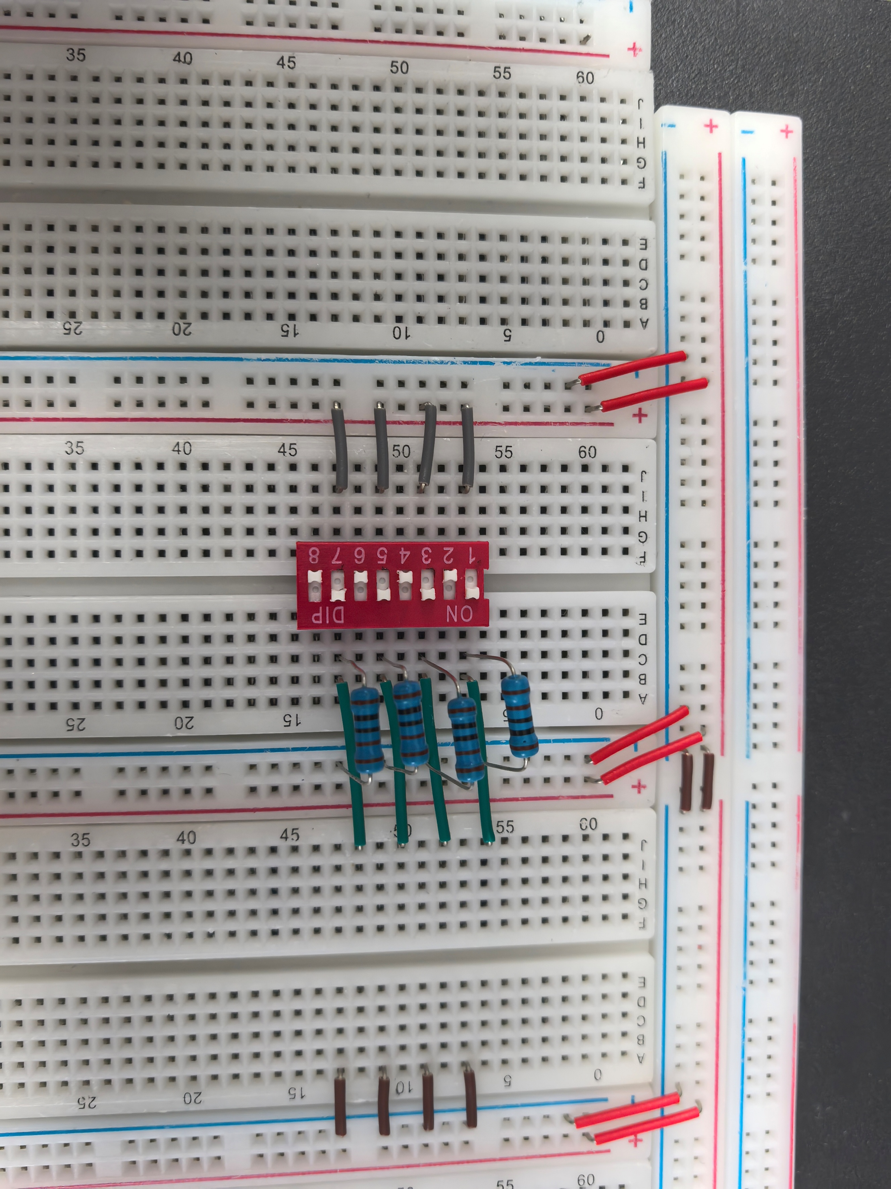

[(B) Measure voltage of each of the logic sources when its corresponding switch is open or closed. Briefly explain the logic levels produced in each of the two switch states (open or closed)] (2 points)

|  |  |
| --- | --- |
| OPEN | CLOSE |
| 0.637mV | 4.9956V |
| 0.655mV | 4.9957V |
| 0.214mV | 4.9963V |
| 0.009mV | 4.9959V |

When the switch is open, the state is low level with lower voltage

When the switch is closed, the state is high level with higher voltage.

**Logic Source, 470 (or close to) Ohm Resistor, and LED in Series**

[(A) Insert a picture of your build of the circuit in Figure 2] (1 point)

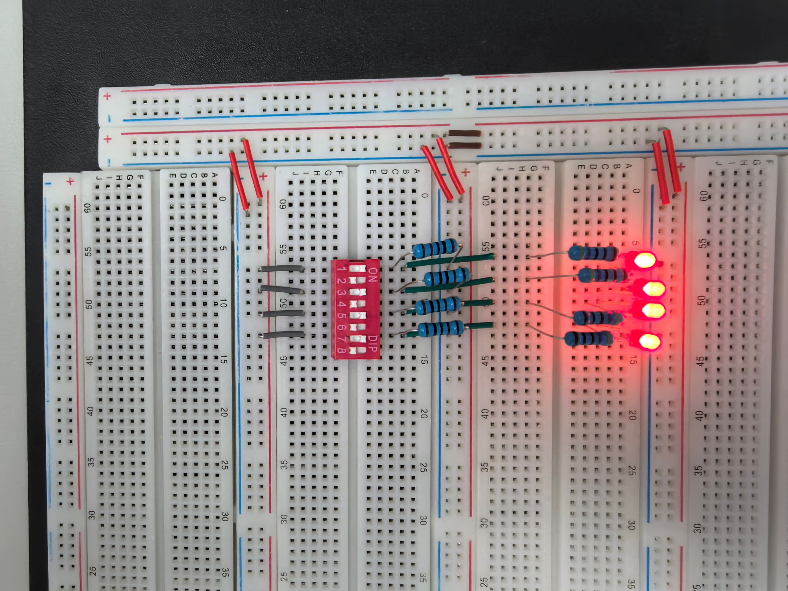

[(B) Fill out the following information] (2 points)

Vx when switch 1 is closed = 4.9917V

Vx when switch 1 is opened = 0.908mV

LED 1 state (on/off) when switch 1 is open = OFF

LED 1 state (on/off) when switch 1 is closed = ON

Vx when switch 2 is closed = 4.9920V

Vx when switch 2 is opened = 0.923mV

LED 2 state (on/off) when switch 2 is open = OFF

LED 2 state (on/off) when switch 2 is closed = ON

Vx when switch 3 is closed = 4.9920V

Vx when switch 3 is opened = 0.927mV

LED 3 state (on/off) when switch 3 is open = OFF

LED 3 state (on/off) when switch 3 is closed = ON

Vx when switch 4 is closed = 4.9901V

Vx when switch 4 is opened = 0.932mV

LED 4 state (on/off) when switch 4 is open = OFF

LED 4 state (on/off) when switch 4 is closed = ON

[(C) Briefly explain why the logic levels produced are valid/invalid in each of the two switch states (open or closed)] (1 point)

The logic levels are valid because they fall within the acceptable voltage thresholds for TTL logic.

When the switch is open, the input voltage is near 0 V, which is below 1.5 V and therefore recognized as a valid logic low (0).

When the switch is closed, the input voltage is near 5 V, which is above 3.5 V and therefore recognized as a valid logic high (1).

**Part II: Two-Bit Multiplier Logic Design (12 points)**

**Truth Table**

[(A) Fill out the following truth table for a 2-bit Multiplier as shown in Table 1] (2 points)

|  |  |  |  |  |  |  |  |
| --- | --- | --- | --- | --- | --- | --- | --- |
| A1 | A0 | B1 | B0 | P3 | P2 | P1 | P0 |
| 0 | 0 | 0 | 0 | 0 | 0 | 0 | 0 |
| 0 | 0 | 0 | 1 | 0 | 0 | 0 | 0 |
| 0 | 0 | 1 | 0 | 0 | 0 | 0 | 0 |
| 0 | 0 | 1 | 1 | 0 | 0 | 0 | 0 |
| 0 | 1 | 0 | 0 | 0 | 0 | 0 | 0 |
| 0 | 1 | 0 | 1 | 0 | 0 | 0 | 1 |
| 0 | 1 | 1 | 0 | 0 | 0 | 1 | 0 |
| 0 | 1 | 1 | 1 | 0 | 0 | 1 | 1 |
| 1 | 0 | 0 | 0 | 0 | 0 | 0 | 0 |
| 1 | 0 | 0 | 1 | 0 | 0 | 1 | 0 |
| 1 | 0 | 1 | 0 | 0 | 1 | 0 | 0 |
| 1 | 0 | 1 | 1 | 0 | 1 | 1 | 0 |
| 1 | 1 | 0 | 0 | 0 | 0 | 0 | 0 |
| 1 | 1 | 0 | 1 | 0 | 0 | 1 | 1 |
| 1 | 1 | 1 | 0 | 0 | 1 | 1 | 0 |
| 1 | 1 | 1 | 1 | 1 | 0 | 0 | 1 |

**Circuit Design Schematics**

[(A) Determine the logic function for P0 and draw the schematic of your design] (1 point)

Logic function:

$$P_{0}=A_{0}B_{0}$$

Schematic

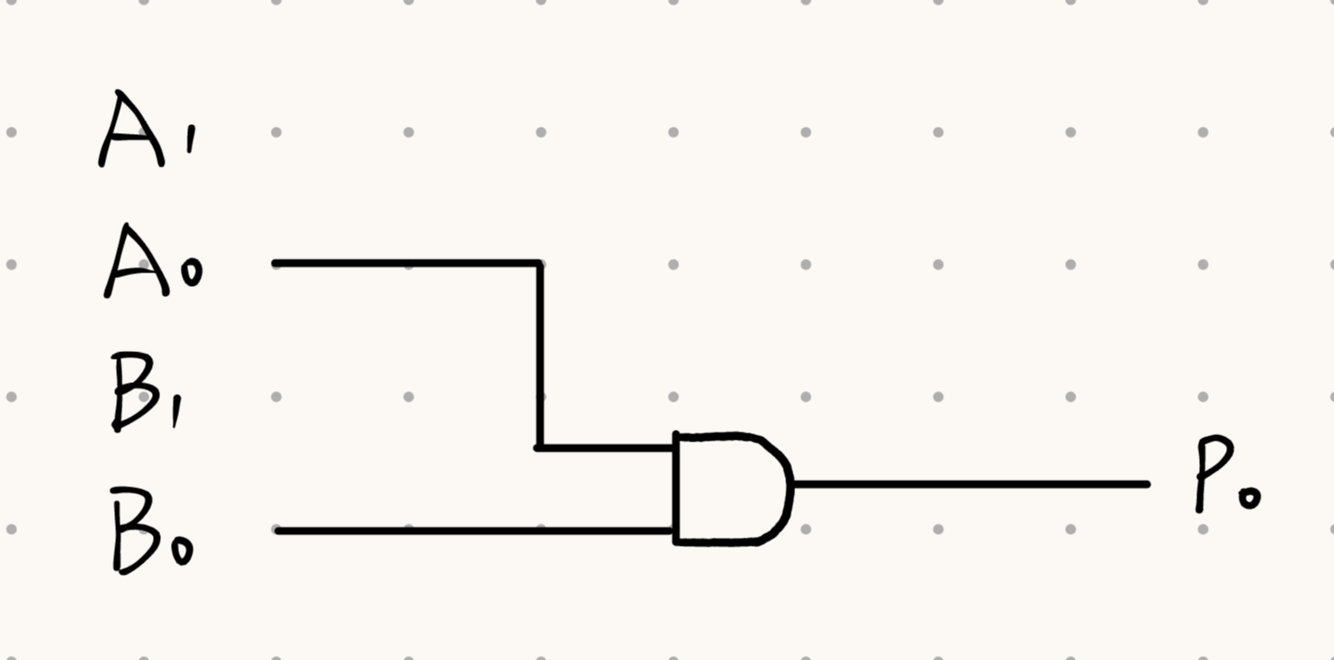

[(B) Determine the logic function of P0 and P3 and draw the schematic of a circuit that produces both] (2 points)

Logic function:

$$P_{0}=A_{0}B_{0}$$

$$P_{3}=A_{0}A_{1}B_{0}B_{1}$$

Schematic:

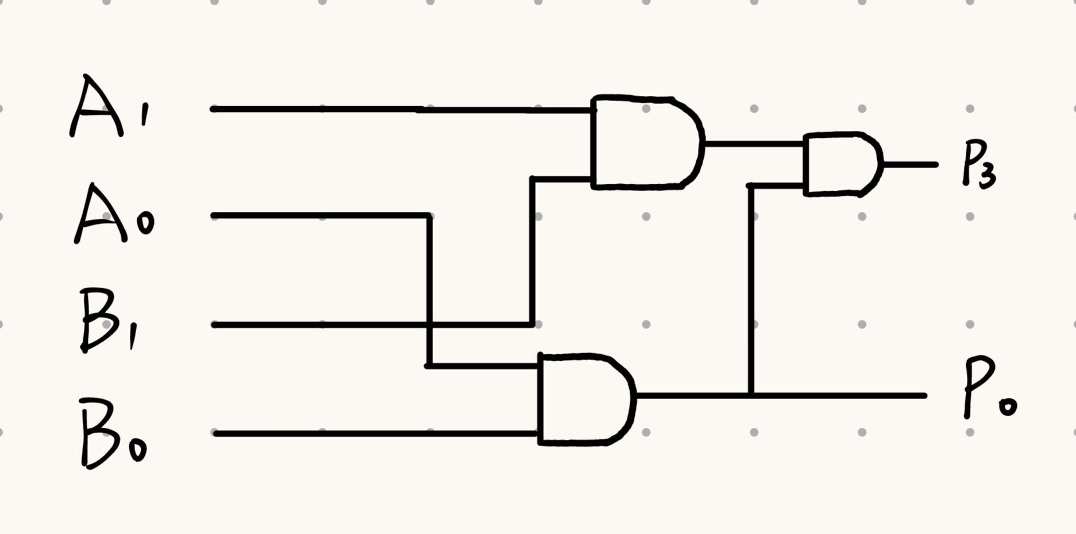

[(C) Determine the logic function of P0, P2, and P3 and draw the schematic of a circuit that produces all three] (3 points)

Logic function:

$$P_{0}=A_{0}B_{0}$$

$${P_{2}=A}_{1}B_{1}{\left(A_{0}B_{0}\right)}^{'}$$

$$P_{3}=A_{1}A_{0}B_{1}B_{0}$$

Schematic:

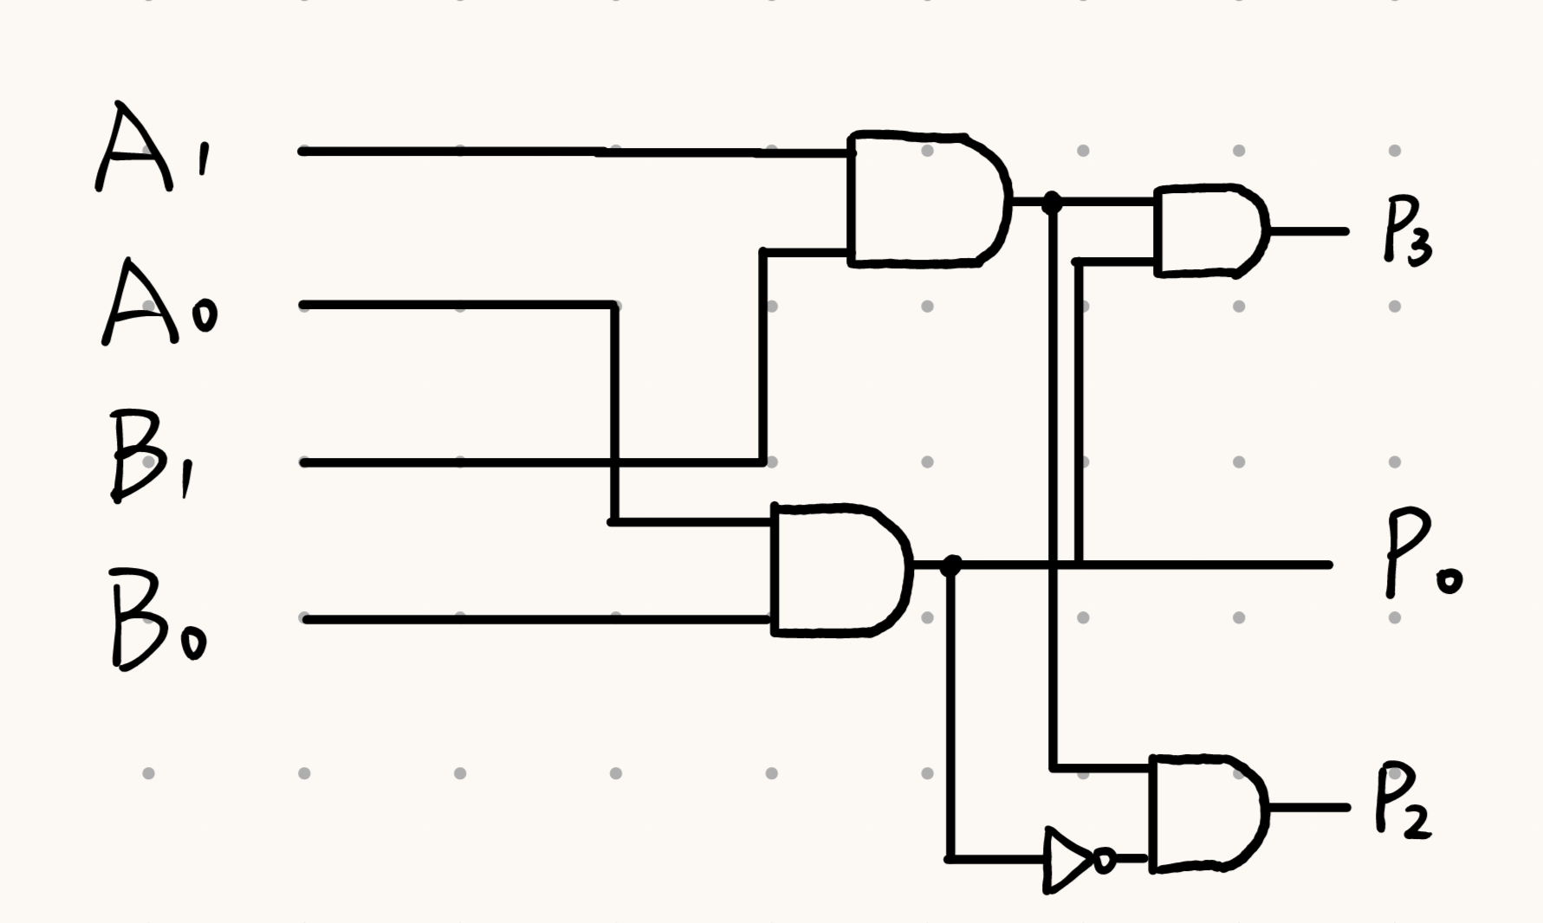

**Complete Two-Bit Multiplier**

[(A) Determine the logic function of P0, P1, P2, and P3. Draw the schematic of your design of a complete two-bit multiplier] (4 points)

Logic function: $P_{0}=A_{0}B_{0};P_{1}=\left(A_{1}B_{0}\right)⊕\left(A_{0}B_{1}\right);P_{2}=A_{1}B_{1}{\left(A_{0}B_{0}\right)}^{'};P_{3}=A_{1}A_{0}B_{1}B_{0}$

Schematic:

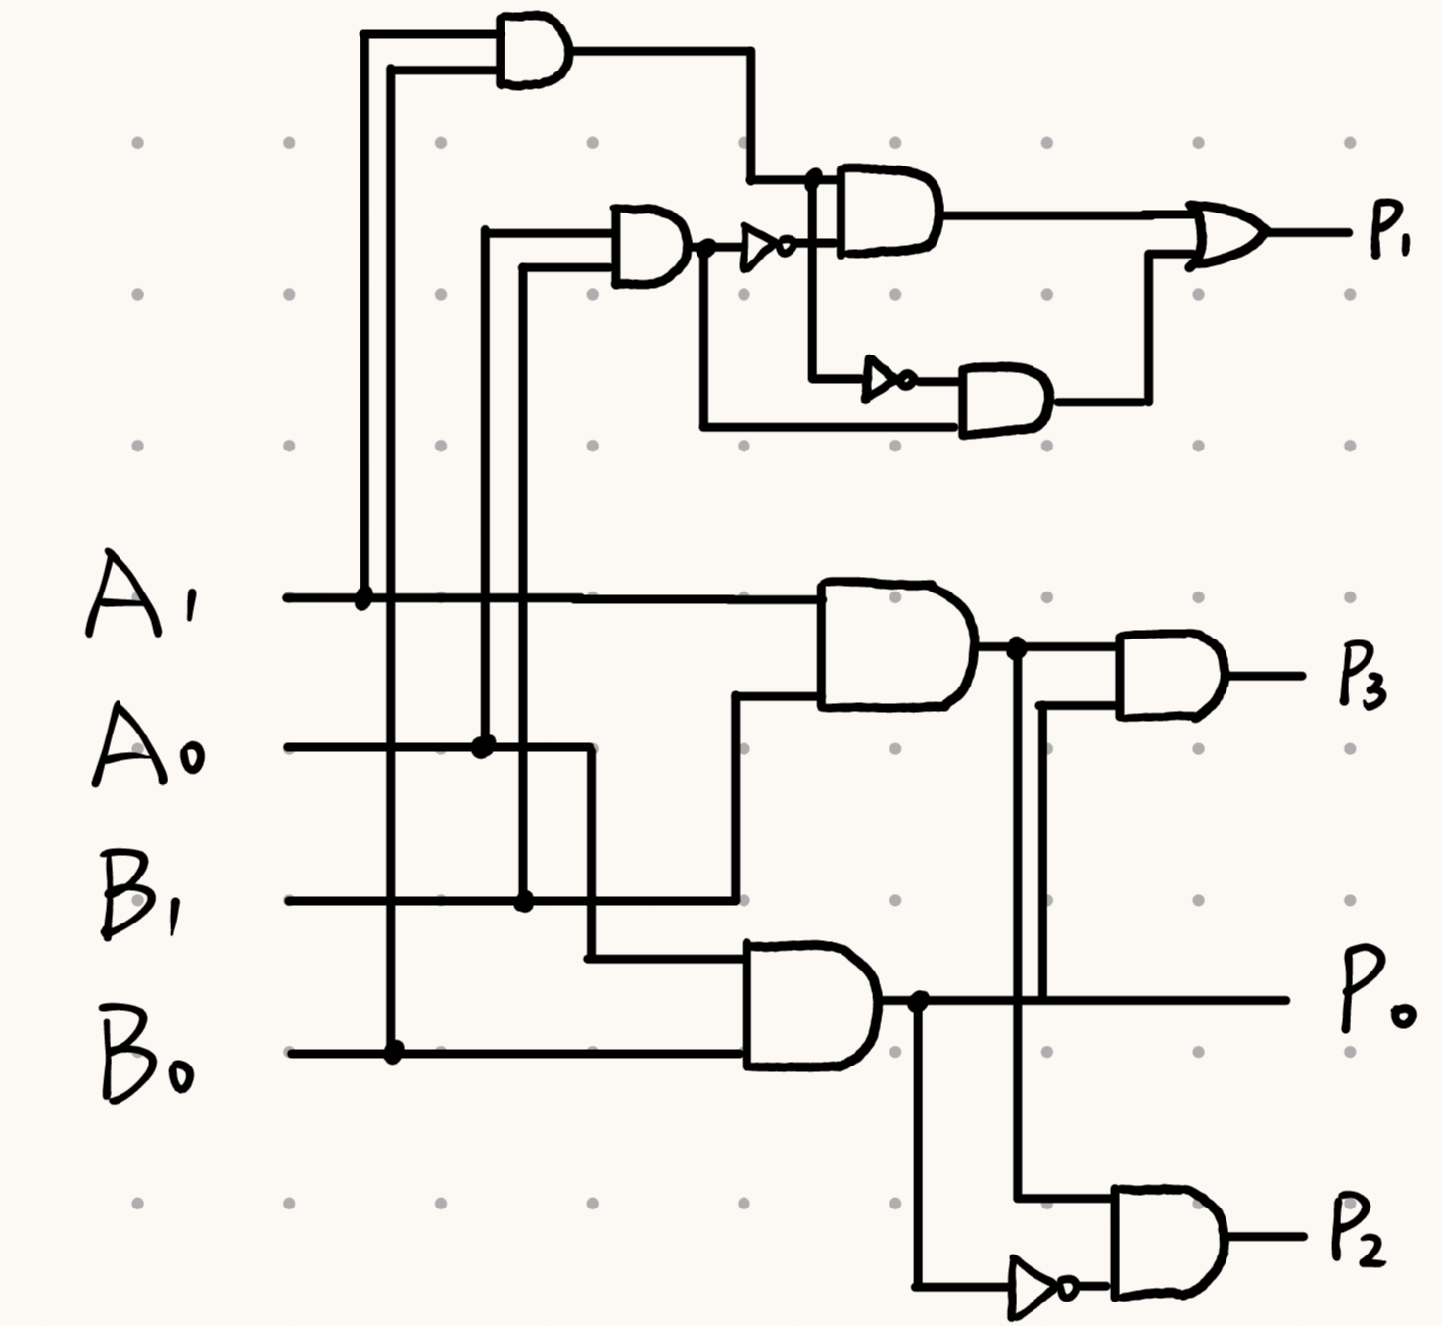

**Part III: Two-Bit Multiplier Implementation (26 points)**

**Circuit with Output P0**

[(A) Insert a picture of your build of the circuit you designed to produce P0] (1 point)

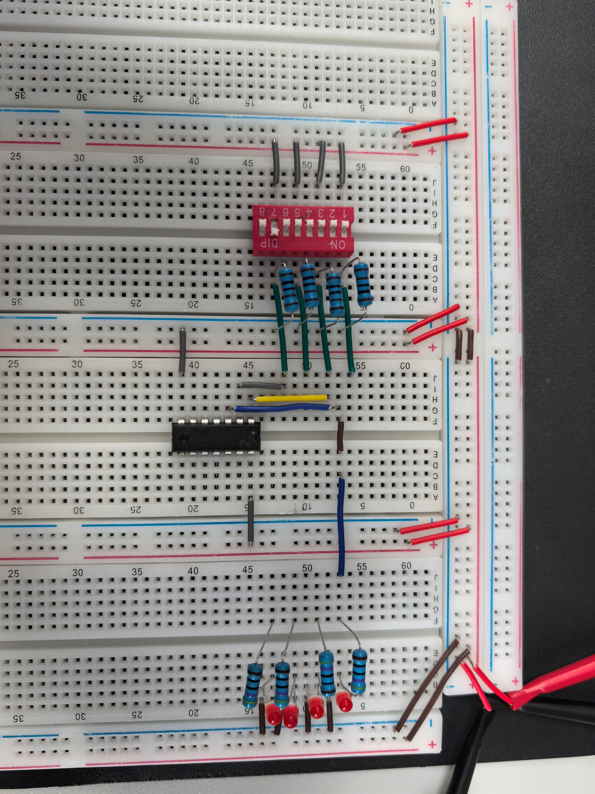

[(B) Fill out the following information] (2 points)

|  |  |  |  |  |
| --- | --- | --- | --- | --- |
| S1 | S2 | S3 | S4 | LED P0 (on/off) |
| Open | Open | Open | Open | OFF |
| Open | Open | Open | Closed | OFF |
| Open | Open | Closed | Open | OFF |
| Open | Open | Closed | Closed | OFF |
| Open | Closed | Open | Open | OFF |
| Open | Closed | Open | Closed | ON |
| Open | Closed | Closed | Open | OFF |
| Open | Closed | Closed | Closed | ON |
| Closed | Open | Open | Open | OFF |
| Closed | Open | Open | Closed | OFF |
| Closed | Open | Closed | Open | OFF |
| Closed | Open | Closed | Closed | OFF |
| Closed | Closed | Open | Open | OFF |
| Closed | Closed | Open | Closed | ON |
| Closed | Closed | Closed | Open | OFF |
| Closed | Closed | Closed | Closed | ON |

**Circuit with Outputs P0 and P3**

[(A) Insert a picture of your build of the circuit you designed to produce P0 and P3] (1 point)

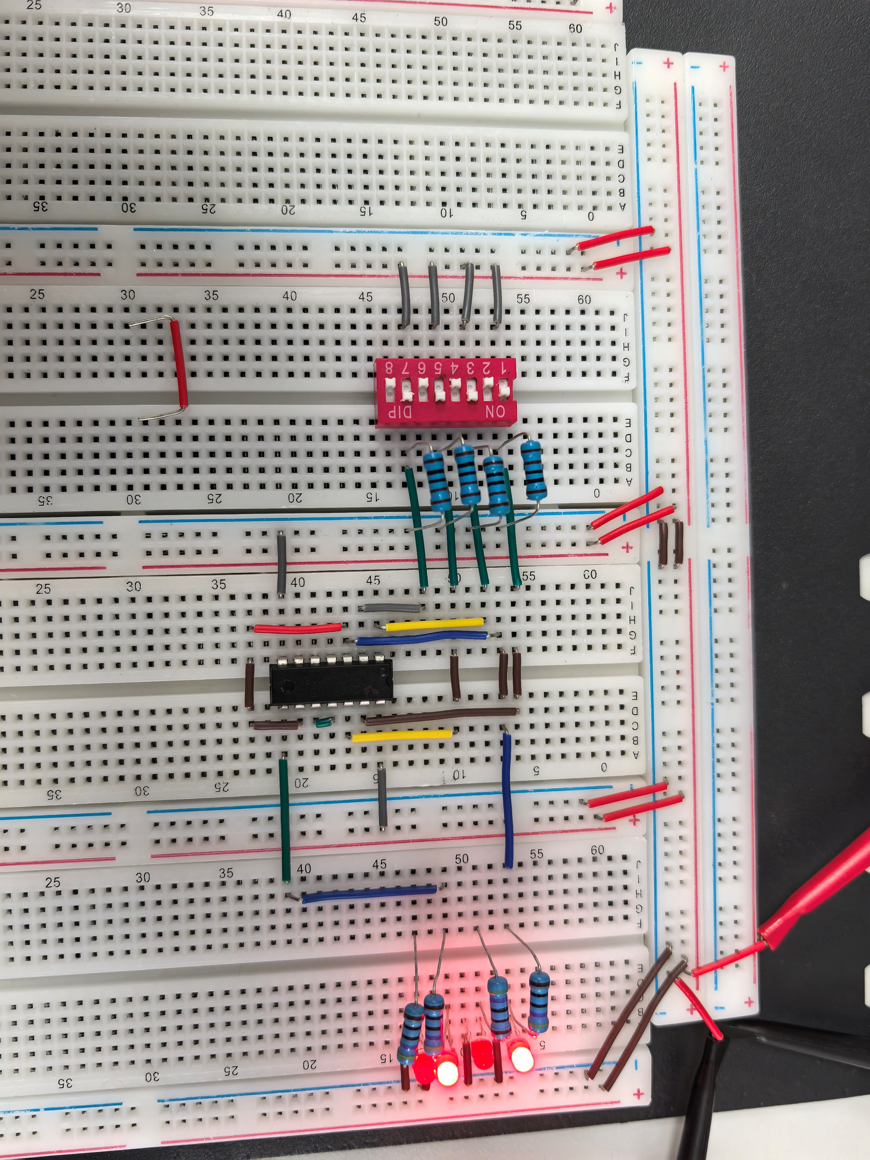

[(B) Fill out the following information] (2 points)

|  |  |  |  |  |  |
| --- | --- | --- | --- | --- | --- |
| S1 | S2 | S3 | S4 | LED P3 (on/off) | LED P0 (on/off) |
| Open | Open | Open | Open | OFF | OFF |
| Open | Open | Open | Closed | OFF | OFF |
| Open | Open | Closed | Open | OFF | OFF |
| Open | Open | Closed | Closed | OFF | OFF |
| Open | Closed | Open | Open | OFF | OFF |
| Open | Closed | Open | Closed | OFF | ON |
| Open | Closed | Closed | Open | OFF | OFF |
| Open | Closed | Closed | Closed | OFF | ON |
| Closed | Open | Open | Open | OFF | OFF |
| Closed | Open | Open | Closed | OFF | OFF |
| Closed | Open | Closed | Open | OFF | OFF |
| Closed | Open | Closed | Closed | OFF | OFF |
| Closed | Closed | Open | Open | OFF | OFF |
| Closed | Closed | Open | Closed | OFF | ON |
| Closed | Closed | Closed | Open | OFF | OFF |
| Closed | Closed | Closed | Closed | ON | ON |

**Circuit with Outputs P0, P2, and P3**

[(A) Insert a picture of your build of the circuit you designed to produce P0, P2, and P3] (1 point)

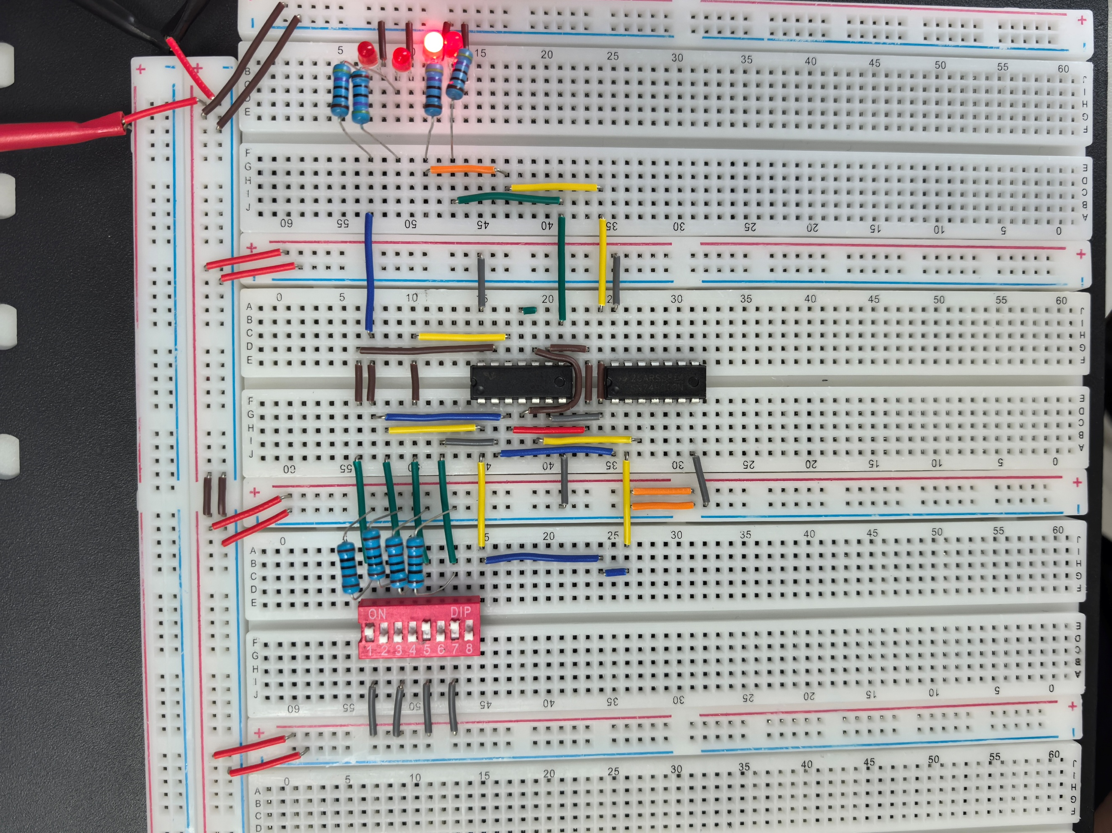

[(B) Fill out the following information] (2 points)

|  |  |  |  |  |  |  |
| --- | --- | --- | --- | --- | --- | --- |
| S1 | S2 | S3 | S4 | LED P3 (on/off) | LED P2 (on/off) | LED P0 (on/off) |
| Open | Open | Open | Open | OFF | OFF | OFF |
| Open | Open | Open | Closed | OFF | OFF | OFF |
| Open | Open | Closed | Open | OFF | OFF | OFF |
| Open | Open | Closed | Closed | OFF | OFF | OFF |
| Open | Closed | Open | Open | OFF | OFF | OFF |
| Open | Closed | Open | Closed | OFF | OFF | ON |
| Open | Closed | Closed | Open | OFF | OFF | OFF |
| Open | Closed | Closed | Closed | OFF | OFF | ON |
| Closed | Open | Open | Open | OFF | OFF | OFF |
| Closed | Open | Open | Closed | OFF | OFF | OFF |
| Closed | Open | Closed | Open | OFF | ON | OFF |
| Closed | Open | Closed | Closed | OFF | ON | OFF |
| Closed | Closed | Open | Open | OFF | OFF | OFF |
| Closed | Closed | Open | Closed | OFF | OFF | ON |
| Closed | Closed | Closed | Open | OFF | ON | OFF |
| Closed | Closed | Closed | Closed | ON | OFF | ON |

**Complete Circuit (P0, P1, P2, P3)**

[(A) Insert a picture of your build of the circuit you designed to produce P0, P2, and P3] (1 point)

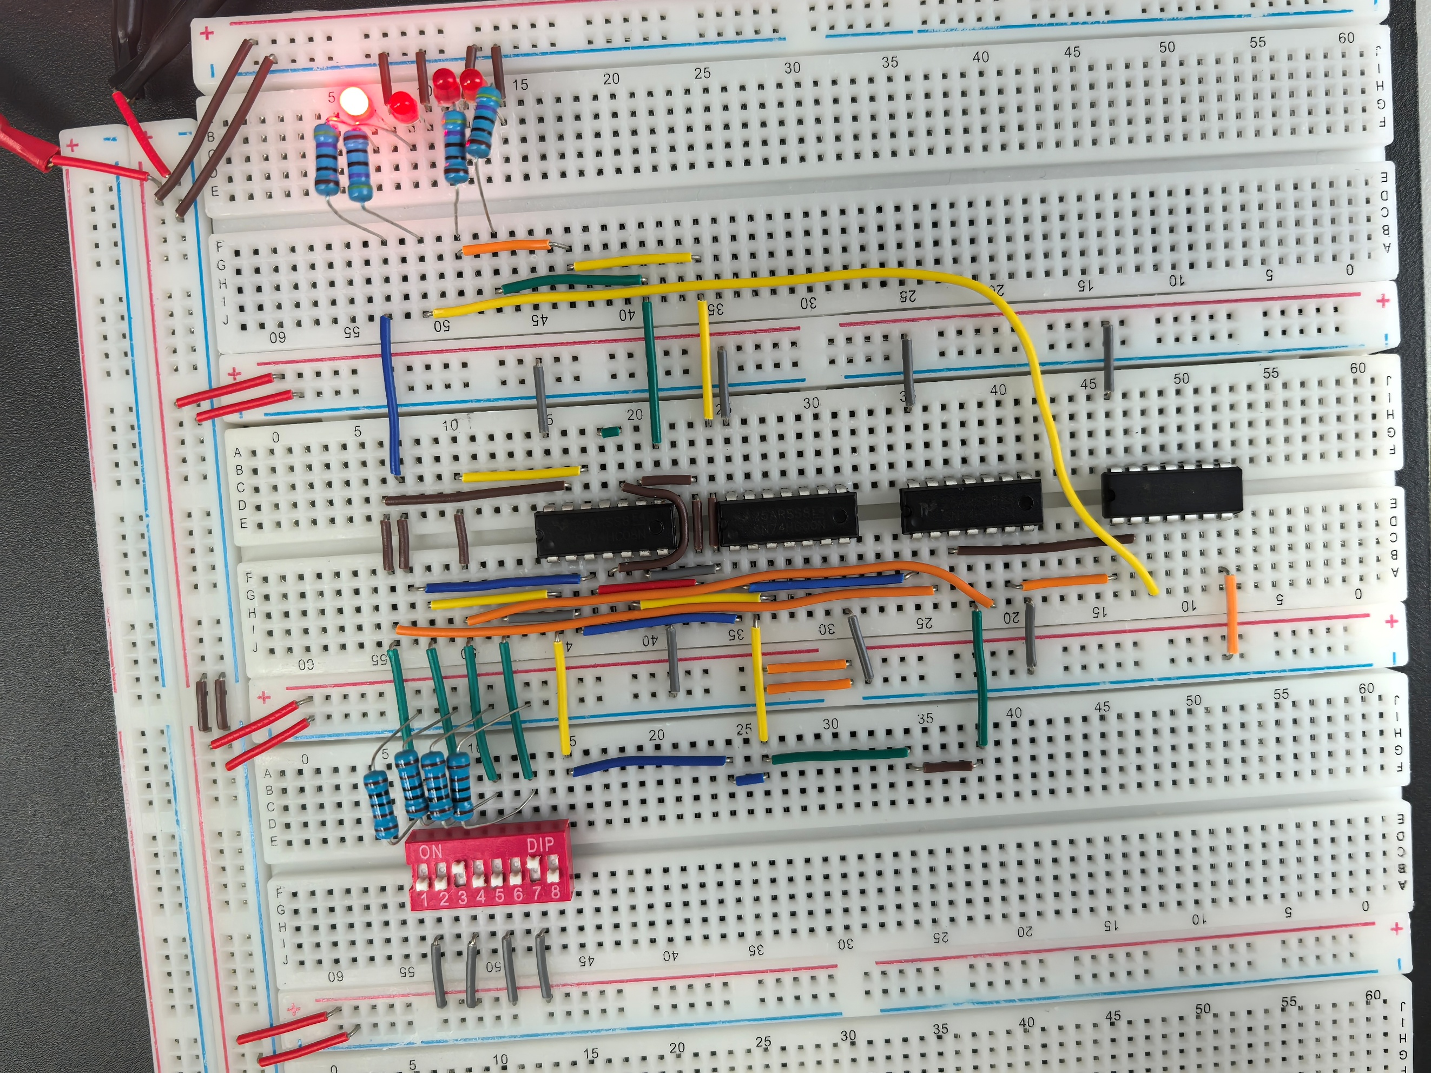

[(B) Fill out the following information] (2 points)

|  |  |  |  |  |  |  |  |
| --- | --- | --- | --- | --- | --- | --- | --- |
| S1 | S2 | S3 | S4 | LED P3 (on/off) | LED P2 (on/off) | LED P1 (on/off) | LED P0 (on/off) |
| Open | Open | Open | Open | OFF | OFF | OFF | OFF |
| Open | Open | Open | Closed | OFF | OFF | OFF | OFF |
| Open | Open | Closed | Open | OFF | OFF | OFF | OFF |
| Open | Open | Closed | Closed | OFF | OFF | OFF | OFF |
| Open | Closed | Open | Open | OFF | OFF | OFF | OFF |
| Open | Closed | Open | Closed | OFF | OFF | OFF | ON |
| Open | Closed | Closed | Open | OFF | OFF | ON | OFF |
| Open | Closed | Closed | Closed | OFF | OFF | ON | ON |
| Closed | Open | Open | Open | OFF | OFF | OFF | OFF |
| Closed | Open | Open | Closed | OFF | OFF | ON | OFF |
| Closed | Open | Closed | Open | OFF | ON | OFF | OFF |
| Closed | Open | Closed | Closed | OFF | ON | ON | OFF |
| Closed | Closed | Open | Open | OFF | OFF | OFF | OFF |
| Closed | Closed | Open | Closed | OFF | OFF | ON | ON |
| Closed | Closed | Closed | Open | OFF | ON | ON | OFF |
| Closed | Closed | Closed | Closed | ON | OFF | OFF | ON |

**[(C) Demonstrate constructed complete circuit to TA for check-off] (14 points)**

**EXTRA PAGES**

[Leave the page unchanged if you are not going to use. Otherwise, specify the problem number you are working on here. Don’t forget to notify “TO BE CONTINUED” in the original problem box]

**EXTRA PAGES**

[Leave the page unchanged if you are not going to use. Otherwise, specify the problem number you are working on here. Don’t forget to notify “TO BE CONTINUED” in the original problem box]

**EXTRA PAGES**

[Leave the page unchanged if you are not going to use. Otherwise, specify the problem number you are working on here. Don’t forget to notify “TO BE CONTINUED” in the original problem box]